**CIS 375 – Fall 2019 Term Project - BRAINS**

Use Case Specification Document

**4**

**Report Generation**

**Version No. 1.0.0**

Project Document Revision History

|  |  |  |  |
| --- | --- | --- | --- |
| VersionNumber | Date | Revision Author | Description of Revision |
| 1.0.0 | 10/28/2019 | Kevin Longworth | Creating of document |
|  |  |  |  |

|  |
| --- |
| **Table of Contents** |

1. Introduction 4

2. Use Case Information 4

2.1 Actors 4

2.2 Use Case Interaction 4

3. Trigger 4

4. Pre-condition(s) 4

4.1 The user is logged in as an oversight team member 4

4.2 There are STENERs that exist 4

5. Post-condition(s) 5

5.1 A report is created 5

5.2 An email is sent to the auditing company if needed 5

5.3 A report could not be created due to invalid criteria 5

6. Use Case Swimlane (Activity) Diagram 5

7. Main/Basic Flow(s) of Events (Happy Path) 5

7.1 The report is generated with the right criteria 5

7.2 A report is sent via email 5

8. Alternate/Exception Flow of Events 6

8.1 Due to invalid criteria, a report cannot be made 6

9. Assumptions/Business Rules including Non-Functional Requirements 6

10. Use Case Specification Review and Signoff 6

# Introduction

This use case encapsulates the functionality of the oversight team generating a report about the STENER’s, as well as giving the report to a possible audit team when needed.

# Use Case Information

## Actors

An actor is someone or something (e.g. application system) outside the system or business that interacts with the application. For every Use Case, there must be at least one Main Actor and zero or more Secondary Actors. Actors should be a person, system, or time.

|  |  |  |
| --- | --- | --- |
| Actor Name | Role | Description |
| Oversight team | Main | Generate the report as they specify |
| Audit company | Main | Generate or receive reports |
| Database | Secondary | Pulls and sorts the data and sends back the report |

## Use Case Interaction

How does this use case relate to other uses cases? List predecessor and successor use cases.

Predecessors:

1. Use case 1:
   1. The STENERS must be submitted before reports can be generated
2. Use Case 2:
   1. The user must login before creating a report
3. Use case 5:
   1. A STENER must be created before it can be used for a report

# Trigger

What causes the use case to initiate?

An oversight team member is logged in and selects criterion for the report, and then asks for the system to generate a report.

# Pre-condition(s)

What use cases or other pre-conditions must be met before use can initiate?

## The user is logged in as an oversight team member

## There are STENERs that exist

# Post-condition(s)

What are ALL the possible output states upon completion of the use case flows?

## A report is created

## An email is sent to the auditing company if needed

## A report could not be created due to invalid criteria

# Use Case Swimlane (Activity) Diagram

Draw diagram(s) that cover ALL main and alternate flows.

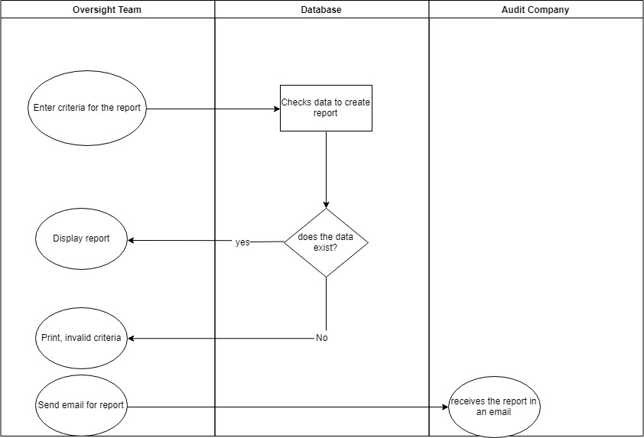

# Main/Basic Flow(s) of Events (Happy Path)

For each main flow (usually ONE flow) write the list of steps that occur – describe WHAT occurs not HOW to do it!

## The report is generated with the right criteria

## A report is sent via email

# Alternate/Exception Flow of Events

For each alternative flow (can be zero or more) write the list of steps that occur – describe WHAT occurs not HOW to do it!

## Due to invalid criteria, a report cannot be made

# Assumptions/Business Rules including Non-Functional Requirements

The users have correct access to be in the oversight team page or part of the auditing company to receive the email.

# Use Case Specification Review and Signoff

|  |  |  |  |
| --- | --- | --- | --- |
| Review and Signoff of the Use Case Specification | | | |
| Name | Project Team Role | Signature | Date |
| Ahmed, Zakariya | Senior Tech Lead/SPMP manager |  | 10/28/19 |
| Alhaidar, Muaz | Developer |  | 10/28/19 |
| Longworth, Kevin | Developer | K.L. | 10/28/19 |
| Labut, Cameron | Developer |  | 10/28/19 |
| Majzoub, Mostafa El | Developer |  | 10/28/19 |

# 